The Induced Magnetic Fields Within Solenoids of Varying Turn Numbers

# Table of Contents

**Table of Contents** **1**

**Introduction** **2**

Research Question 2

Background 2

**Variables** **2**

Independent Variable 2

Dependent Variable 3

Constants and Controlled Variables 3

**Hypothesis** **3**

**Method** **4**

Materials 4

Setup Diagram 4

Procedure 4

Safety 5

**Collected Data and Calculations** **5**

Measured Field at no Current and When Connected to Power for Varying Turn Numbers 5

Average Change in Field and Uncertainty for Varying Turn Numbers 6

Calculations 6

Average Change in Field 6

Uncertainties 7

Total Percent Uncertainty 7

**Graphical Representation** **8**

Calculations 8

Trendline 8

Maximum and Minimum Slope 8

**Conclusion** **9**

Limitations 10

Uncontrolled Variables 11

**Works Cited** **12**

**Appendix A: Raw Data** **13**

# Introduction

I have always been interested in electricity and magnetism because, from as early on as I can remember, it has always seemed like magic to me. And, as I grew up, read science fiction books, and immersed myself in crazy futuristic worlds, it always seemed like magnets played a crucial role in powering those high tech gadgets. Because of this, I have chosen to investigate magnetism for this assessment because I want to understand how magnetism works, and how it can be applied to real world situations to solve problems and further society.

## Research Question

How does the number of turns in a solenoid affect the magnetic field it is able to induce when a current is applied?

## Background

When a current runs through a conductor, it induces a magnetic field that is perpendicular to the direction of the flow of the current. This is described by Ampere’s Law:

[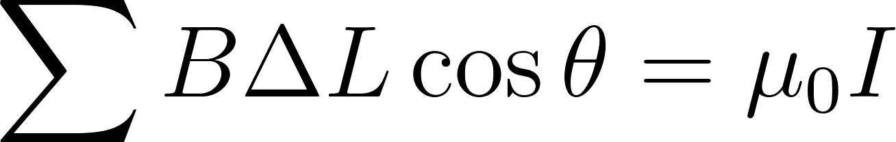](https://www.codecogs.com/eqnedit.php?latex=%5Csum%20B%20%5CDelta%20L%20%5Ccos%7B%5Ctheta%7D%20%3D%20%5Cmu_0%20I#0)

From this, an equation for the magnetic field inside a solenoidal inductor can be derived:

[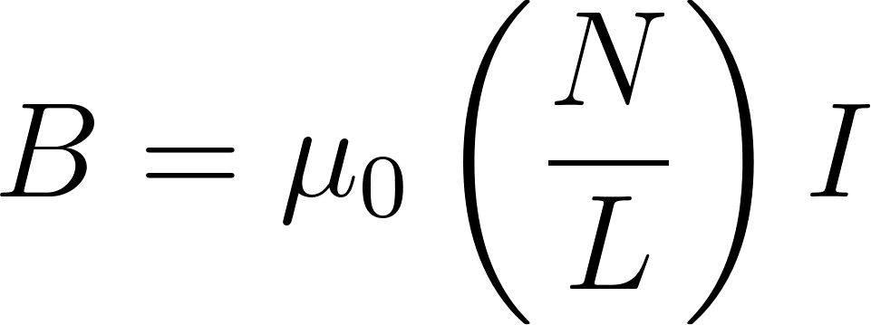](https://www.codecogs.com/eqnedit.php?latex=B%3D%5Cmu_0%5Cleft(%5Cfrac%7BN%7D%7BL%7D%5Cright)I#0)

Where [](https://latex-staging.easygenerator.com/eqneditor/editor.php?latex=N#0) is the number of turns of the solenoid, [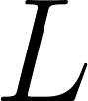](https://www.codecogs.com/eqnedit.php?latex=L#0) is the length of the solenoid, [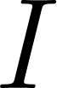](https://www.codecogs.com/eqnedit.php?latex=I#0) is the current flowing through the inductor, and [](https://www.codecogs.com/eqnedit.php?latex=%5Cmu_0#0) is the permeability of free space given by:

[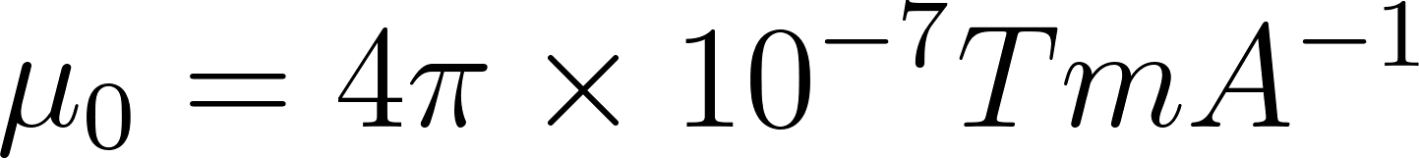](https://www.codecogs.com/eqnedit.php?latex=%5Cmu_0%3D4%5Cpi%20%5Ctimes%2010%5E%7B-7%7D%20TmA%5E%7B-1%7D#0)

# Variables

## Independent Variable

The independent variable for this experiment is the number of turns of wire in the solenoid.

## Dependent Variable

The dependent variable in this experiment is the change in magnetic field produced when a constant voltage is applied across the terminals of the solenoid. This field was measured in the units of micro teslas (mT).

## Constants and Controlled Variables

When performing this experiment, there were a number of variables held constant or controlled throughout. Most importantly, the number of turns in the solenoid was held at constant intervals of 25 from 50 turns to 150 turns. Other variables that were held constant were the gauge and type of wire used, and the radius of the object used to wrap the wire.

Importantly, some variables were not controlled during this experiment. The length of the solenoids across different turn numbers, as well as the exact placement of the magnetic field sensor inside the solenoids was not held constant.

# Hypothesis

As the number of turns in the inductor increases, the strength of the magnetic field induced will increase proportionally due to the relationship between current and magnetic field described by Ampere’s law.

# Method

## Materials

* A cylindrical object to act as a guide when wrapping the solenoids. For this experiment, a length of PVC tubing was used at a diameter of 2.54 cm.
* 28 gauge magnet wire, a minimum of 38 meters is required.
* A data logger.
* A magnetic field sensor.
* A double-A battery at 1.5 volts. This will act as the power source for the solenoid.

## Setup Diagram

# 

## Procedure

1. Use the cylindrical object as a guide to wrap the wire, beginning with 50 turns. This will be repeated to create solenoids of 50, 75, 100, 125, and 150 turns.
2. Set up the experiment as shown in the diagram, connecting the field sensor to the data logger and placing it in the center of the solenoid.
3. While the solenoid is disconnected from the power source, record the reading on the data logger. This will be the ambient reading.
4. Connect the solenoid to the power source, and record the reading on the data logger. This will be the active reading.
5. Disconnect the solenoid from the power source and repeat from step 3 for a total of 5 trials.
6. Remove the solenoid of 50 turns and replace it with the solenoid of 75 turns.
7. Repeat steps 3 through 5 for the solenoid of 75 turns.
8. Remove the solenoid of 75 turns and replace it with the solenoid of 100 turns.
9. Repeat steps 3 through 5 for the solenoid of 100 turns.
10. Remove the solenoid of 100 turns and replace it with the solenoid of 125 turns.
11. Repeat steps 3 through 5 for the solenoid of 125 turns.
12. Remove the solenoid of 125 turns and replace it with the solenoid of 150 turns.
13. Repeat steps 3 through 5 for the solenoid of 150 turns.

## Safety

As this experiment deals with current and electricity, insulation is required in order to minimize the risk of electric shock.

# Collected Data and Calculations

## Measured Field at no Current and When Connected to Power for Varying Turn Numbers

| Number Of Turns | | Magnetic Field  (mT ± 0.0001 mT) | | | | |
| --- | --- | --- | --- | --- | --- | --- |
| Trail 1 | Trial 2 | Trail 3 | Trail 4 | Trail 5 |
| 50 Turns | Ambient | 0.0009 | 0.0012 | 0.0007 | 0.0014 | 0.0008 |
| Active | 0.0084 | 0.0091 | 0.0094 | 0.0083 | 0.0089 |
| 75 Turns | Ambient | 0.0012 | 0.0016 | 0.0016 | 0.0022 | 0.0015 |
| Active | 0.0104 | 0.0101 | 0.0111 | 0.0107 | 0.0106 |
| 100 Turns | Ambient | 0.0013 | 0.0012 | 0.0007 | 0.0011 | 0.0010 |
| Active | 0.0115 | 0.0122 | 0.0119 | 0.0125 | 0.0127 |
| 125 Turns | Ambient | 0.0019 | 0.0017 | 0.0022 | 0.0011 | 0.0014 |
| Active | 0.0134 | 0.0132 | 0.0135 | 0.0137 | 0.0131 |
| 150 Turns | Ambient | 0.0013 | 0.0016 | 0.0023 | 0.0012 | 0.0019 |
| Active | 0.0151 | 0.0148 | 0.0156 | 0.0152 | 0.0155 |

## Average Change in Field and Uncertainty for Varying Turn Numbers

| Number of Turns | Average Change  (mT) | Uncertainty  (±mT) | Percent Uncertainty  (±%) |
| --- | --- | --- | --- |
| 50 | 0.0078 | 0.0009 | 11.54 |
| 75 | 0.0090 | 0.0005 | 5.56 |
| 100 | 0.0111 | 0.0009 | 8.11 |
| 125 | 0.0117 | 0.0009 | 7.70 |
| 150 | 0.0136 | 0.0004 | 2.94 |

## Calculations

### Average Change in Field

First, the difference between the ambient and active measurement was calculated for each trial. Ex: [](https://www.codecogs.com/eqnedit.php?latex=0.0084%20-%200.0009%20%3D%200.0075#0).

Then, the average field was calculated with the following expression:

[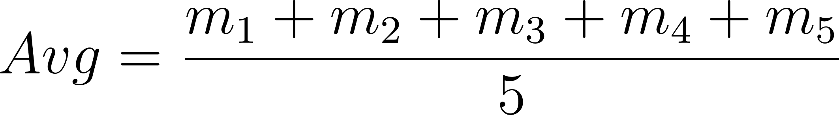](https://www.codecogs.com/eqnedit.php?latex=Avg%20%3D%20%5Cfrac%7Bm_1%20%2B%20m_2%20%2B%20m_3%20%2B%20m_4%20%2B%20m_5%7D%7B5%7D#0)

Where [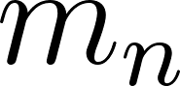](https://www.codecogs.com/eqnedit.php?latex=m_n#0) is the difference calculated in the nth trail.

Ex:

[](https://www.codecogs.com/eqnedit.php?latex=%5Cfrac%7B0.0075%20%2B%200.0079%20%2B%200.0087%20%2B%200.0069%20%2B%200.0081%7D%7B5%7D%20%3D%200.0078#0)

### Uncertainties

The uncertainty was calculated by taking the largest range from the average to each data point. For example, in the run with the coil of 50 turns, the average of the five data points is 0.0078 mT. The ranges from each data point to the average are as follows:

| Measurement (mT) | Calculation | Range (±mT) |
| --- | --- | --- |
| 0.0075 | 0.0078 - 0.0075 | 0.0003 |
| 0.0079 | 0.0078 - 0.0079 | 0.0001 |
| 0.0087 | 0.0078 - 0.0087 | 0.0009 |
| 0.0069 | 0.0078 - 0.0069 | 0.0009 |
| 0.0081 | 0.0078 - 0.0081 | 0.0003 |

The greatest range between the average and a datapoint is 0.0009 mT, therefore the uncertainty for that measurement is ±0.0009 mT

The percent uncertainty can then be found by dividing the uncertainty calculated above by the average of the measurements. The percent uncertainty for the run with 50 turns is [](https://www.codecogs.com/eqnedit.php?latex=0.0009%20%2F%200.0078%20*%20100%20%3D%2011.54%25#0)

### Total Percent Uncertainty

Given that the only measurement with an uncertainty associated with it in this experiment is the measurement of the magnetic field, the total percent uncertainty for this experiment is simply the greatest uncertainty calculated from the collected data. Therefore, the total percent uncertainty for this experiment is 11.54%.

# Graphical Representation

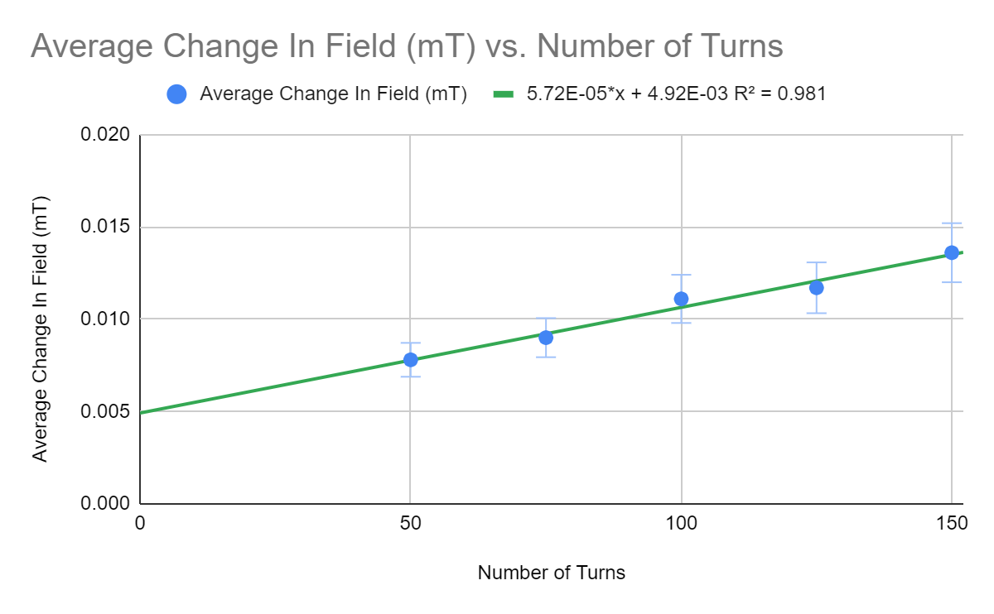

## Calculations

### Trendline

Using a linear regression on the collected data, I estimated the trendline to be:

[](https://www.codecogs.com/eqnedit.php?latex=f(x)%20%3D%20(5.72%5Ccdot%2010%5E%7B-5%7D)x%20%2B%204.92%5Ccdot%2010%5E%7B-3%7D#0)

### Maximum and Minimum Slope

Given the percent uncertainty found earlier, and represented by the error bars on the graph, of 11.54%, the maximums and minimums of the data can be found as follows:

The maximum value of the data at 150 turns is [](https://www.codecogs.com/eqnedit.php?latex=0.0136%20*%201.1154%20%3D%200.0152%20mT#0), and the minimum value is [](https://www.codecogs.com/eqnedit.php?latex=0.0136%20*%20(1%20-%200.1154)%20%3D%200.0120%20mT#0).

The maximum value of the data at 50 turns is [](https://www.codecogs.com/eqnedit.php?latex=0.0078%20*%201.1154%20%3D%200.0087mT#0) and the minimum value at 50 turns is [](https://www.codecogs.com/eqnedit.php?latex=0.0078%20*%20(1%20-%200.1154)%20%3D%200.0069mT#0)

Given these values, the maximum slope can be found:

[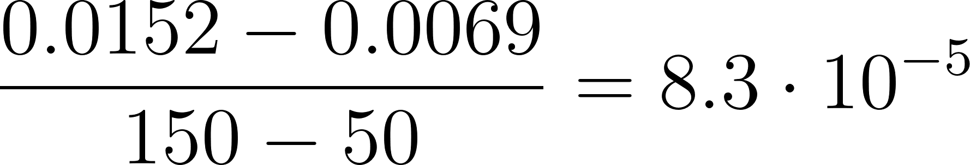](https://www.codecogs.com/eqnedit.php?latex=%5Cfrac%7B0.0152-0.0069%7D%7B150-50%7D%3D8.3%5Ccdot%2010%5E%7B-5%7D#0)

As well as the minimum slope:

[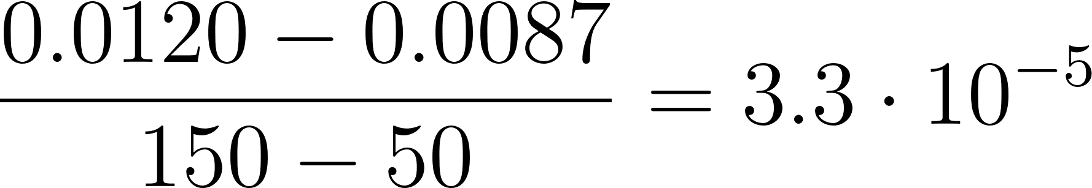](https://www.codecogs.com/eqnedit.php?latex=%5Cfrac%7B0.0120-0.0087%7D%7B150-50%7D%3D3.3%5Ccdot%2010%5E%7B-5%7D#0)

From here, the uncertainty associated with the slope of the trendline can be found by averaging the maximum and minimum slopes like so.

[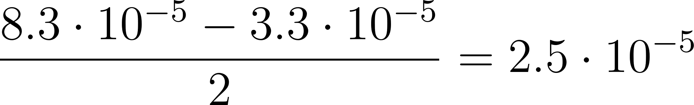](https://www.codecogs.com/eqnedit.php?latex=%5Cfrac%7B8.3%5Ccdot%2010%5E%7B-5%7D%20-%203.3%5Ccdot%2010%5E%7B-5%7D%7D%7B2%7D%3D2.5%5Ccdot%2010%5E%7B-5%7D#0)

The adjusted graph with the lines of maximum and minimum slope can be found below.

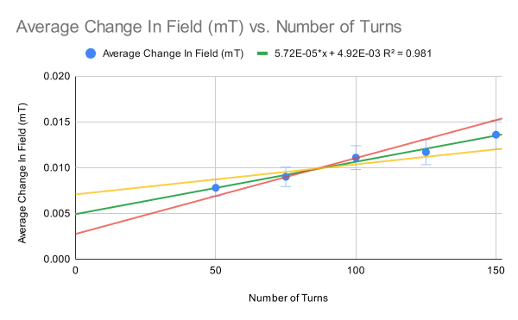

Where ​ is the line of maximum slope, and ​ is the line of minimum slope.

# Conclusion

As indicated by the graph, I found that there is a linear relationship with a slope of [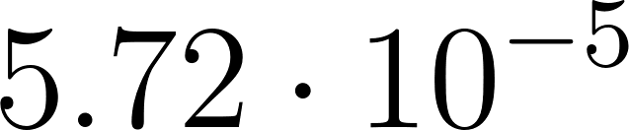](https://latex-staging.easygenerator.com/eqneditor/editor.php?latex=5.72%5Ccdot%2010%5E%7B-5%7D#0) ([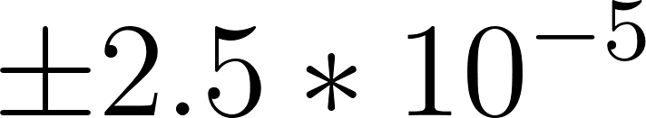](https://www.codecogs.com/eqnedit.php?latex=%5Cpm2.5*10%5E%7B-5%7D#0)) between the number of turns in the solenoid and the change in magnetic field measured when current was applied. This measured relationship had an intercept of [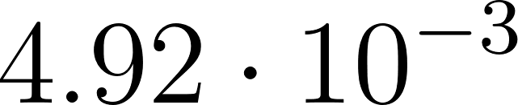](https://www.codecogs.com/eqnedit.php?latex=4.92%5Ccdot%2010%5E%7B-3%7D#0) as well. With a total percent uncertainty of 11.54%.

This does not validate my hypothesis, as I predicted that the relationship between these variables would be proportional, not linear.

The percent uncertainty associated with the measurement of magnetic fields with the magnetometer was 11.54%. This is demonstrated by the error bars present on the graphical representation of the data. These represent the reliability of the data recorded from the magnetic field probe during the experiment. While this uncertainty does provide a maximum and minimum slope value for the possible trend in the data, the minimum slope value still does represent a linear relationship albeit with a larger y-intercept. This total uncertainty can most likely be attributed to several limitations with this experiment, as discussed below.

## Limitations

As discussed earlier, one of the largest limitations associated with this experiment was that the lengths of the solenoids were not held constant. As the derived equation from Ampere’s law describes, the length of the solenoid directly affects the strength of the magnetic field it produces. This uncontrolled variable may have provided another method by which the magnetic field the solenoids induced was changing. Meaning that the measured change in field between solenoids could be attributed to the variance in length of the solenoids rather than the number of turns. Increasing the length of a solenoid relative to the others would lead to a decrease in the strength of the magnetic field that solenoid would produce. Decreasing the length of a solenoid relative to the others would lead to an increase in the strength of the magnetic field that solenoid would produce. This limitation could be rectified by a more comprehensive winding procedure while constructing the solenoids. Specifically, limiting the length of PVC tubing used to wrap the solenoids would ensure a consistent length.

Another limitation associated with this experiment was that current was not measured or regulated. Because of this, there was no way to guarantee that the current flowing through the solenoids was consistent, and therefore it was an uncontrolled variable. As with the length of the solenoids, this uncontrolled variable may have provided another pathway by which the magnetic field strength generated by the solenoids could change. As the power source used was a battery, it is likely that, as trials progressed, the amount of current supplied by the battery slowly depleted. This would affect the results as the later trails and runs with solenoids of greater turns would likely see a lower magnetic field strength than if the current was held constant. A solution to this would be to replace the double-A battery used with a variable current DC power supply. This would allow for fine control over the current flowing through the solenoids and ensure that the only change in magnetic field strength would come from a change in the number of turns.

Finally, the last important limitation to this experiment, as discussed above, is that the placement of the magnetic field probe inside the solenoids was relatively inconsistent. Small changes in the position of the magnetic field probe can lead to inconsistencies in the data as these small changes could lead to slightly different levels of background magnetic field being detected. This most likely affected the experiment when connecting the solenoid to power, as that process could cause small changes in the position of the field sensor. A solution to this would involve constructing holders for both the solenoid cois and the magnetic field probe, to ensure that they can be reliably placed in the same position across trials and runs.

# Works Cited

Department of Physics and Astronomy. “Magnetic Field of a Solenoid.” Michigan State University. Accessed March 20, 2022. <https://web.pa.msu.edu/courses/2000fall/PHY232/lectures/ampereslaw/solenoid.html.>

Ampere’s Law. University of Wisconsin-Madison, 5 Nov. 2020, <https://phys.libretexts.org/@go/page/19535>.

# Appendix A: Raw Data

| Number Of Turns | | Magnetic Field  (mT ± 0.0001 mT) | | | | |
| --- | --- | --- | --- | --- | --- | --- |
| Trail 1 | Trial 2 | Trail 3 | Trail 4 | Trail 5 |
| 50 Turns | Ambient | 0.0009 | 0.0012 | 0.0007 | 0.0014 | 0.0008 |
| Active | 0.0084 | 0.0091 | 0.0094 | 0.0083 | 0.0089 |
| 75 Turns | Ambient | 0.0012 | 0.0016 | 0.0016 | 0.0022 | 0.0015 |
| Active | 0.0104 | 0.0101 | 0.0111 | 0.0107 | 0.0106 |
| 100 Turns | Ambient | 0.0013 | 0.0012 | 0.0007 | 0.0011 | 0.0010 |
| Active | 0.0115 | 0.0122 | 0.0119 | 0.0125 | 0.0127 |
| 125 Turns | Ambient | 0.0019 | 0.0017 | 0.0022 | 0.0011 | 0.0014 |
| Active | 0.0134 | 0.0132 | 0.0135 | 0.0137 | 0.0131 |
| 150 Turns | Ambient | 0.0013 | 0.0016 | 0.0023 | 0.0012 | 0.0019 |
| Active | 0.0151 | 0.0148 | 0.0156 | 0.0152 | 0.0155 |

## 